ISSN 3025-4671
Volume 4 No. 2 Desember 2026, Hal. 172–188

Kemas Journal: Jurnal Pengabdian Masyarakat
https://doi.org/10.31851/kemas.v2i2.16737
https://jurnal.univpgri-palembang.ac.id/index.php/kemas/

Strengthening the Capacities of Coffee Farmers in Patikul, Sulu: A Needs-based Capacity-building Initiative for Kahawa Sug
Arie Kusuma Paksi¹*, Melvin A. Jabar², Abdel Amilhamja³, Fiya Ainur Rohmatika⁴, Waluyo¹, Sri Suharti¹

¹ Department of International Relations, Universitas Muhammadiyah Yogyakarta, Yogyakarta, Indonesia
² Mindanao State University–General Santos, General Santos City, Philippines
³ Graduate Studies, Sulu State University, Philippines
⁴ Center for Development and International Studies, Universitas Muhammadiyah Yogyakarta, Yogyakarta, Indonesia

*Corresponding author: ariekusumapaksi@umy.ac.id

Received: 04 September 2026 Revised: 20 Desember 2044 Accepted: 29 Desember 2044

Abstrak
Budidaya kopi merupakan sumber penghidupan penting bagi rumah tangga pedesaan di Patikul, Sulu, Filipina. Petani menghadapi kendala yang saling berkaitan pada budidaya, penanganan pascapanen, penggunaan input organik, pengemasan, branding, dan akses pasar. Program pengabdian masyarakat internasional Universitas Muhammadiyah Yogyakarta dan Sulu State University menggunakan pendekatan berbasis kebutuhan dan partisipatif melalui konsultasi komunitas, asesmen kebutuhan pelatihan, serta pelatihan dua hari tentang produksi kopi, vermikompos, pemasaran, dan desain kemasan. Asesmen terhadap 21 petani menunjukkan dominasi usaha tani skala kecil yang baru direvitalisasi dan kebutuhan pada bibit bermutu, praktik budidaya dan pascapanen, pupuk organik, serta pengembangan produk berorientasi pasar. Tiga belas petani mengikuti program secara penuh. Evaluasi peserta menunjukkan penerimaan yang sangat positif, sementara hasil tes pengetahuan langsung belum menunjukkan perubahan yang signifikan secara statistik. Program juga menghasilkan konsep kemasan Kahawa Sug yang berakar pada identitas budaya lokal dan agenda tindak lanjut untuk pendampingan, demonstrasi lapangan, penyempurnaan kemasan, serta penguatan jejaring pasar.
Kata kunci: pengabdian masyarakat; petani kopi; penguatan kapasitas; Kahawa Sug; pengembangan partisipatif; Sulu

Abstract
Coffee farming is an important livelihood source for rural households in Patikul, Sulu, Philippines, but farmers face interrelated constraints in cultivation, post-harvest handling, organic input use, branding, packaging, and market access. This study reports an international community engagement initiative implemented by Universitas Muhammadiyah Yogyakarta and Sulu State University to strengthen the capacities of coffee farmers and support the development of Kahawa Sug. The initiative adopted a needs-based and participatory approach comprising a community consultation and training needs assessment, followed by a two-day capacity-building program on coffee production, vermicomposting, branding, marketing, and participatory packaging design. Survey findings from 21 farmers indicated small-scale, recently revitalized coffee production and substantial needs for quality seedlings, improved cultivation and post-harvest practices, organic fertilizer, and market-oriented product development. Thirteen farmers completed the capacity-building program. While Wilcoxon signed-rank tests showed no statistically significant immediate changes in vermicomposting knowledge or coffee farming knowledge, participant evaluations were highly positive. The program also generated a culturally grounded packaging concept for Kahawa Sug. The study demonstrates that international community engagement can strengthen local partnerships, generate relevant capacity-building interventions, and establish foundations for sustained support to smallholder coffee farmers.
Keywords: community engagement; coffee farmers; capacity building; Kahawa Sug; participatory development; Sulu.

Introduction
Coffee farming is an important livelihood source for many rural households in Sulu, Philippines, where locally produced coffee is known as Kahawa Sug. The commodity has economic and cultural importance because it is closely associated with local agricultural traditions and the aspiration to develop a distinctive Sulu coffee identity. Historically, Sulu has been recognized as one of the coffee-producing areas in the Philippines, with an earlier estimate indicating an annual output of approximately 7,300 metric tons [1]. Nevertheless, coffee producers in the province continue to experience interconnected constraints in access to quality planting materials, cultivation practices, farm inputs, post-harvest handling, financing, processing equipment, packaging, labeling, and market access [2], [3]. These constraints reduce product quality, restrict value addition, and limit the ability of smallholder farmers to access broader and more profitable markets.
The challenges are particularly evident in Patikul, Sulu, where this international community engagement initiative was implemented in Barangay Kabbun Takas and Barangay Bacong. Both communities are commonly recognized as balik barangays, or return-to-the-village communities. Many residents had left their homes, farms, and livelihood activities during periods of armed conflict and only gradually returned to their ancestral areas when local security conditions improved. Coffee cultivation has consequently been revived only in recent years, while many farms remain small-scale, dependent on traditional farming practices, and constrained by limited production resources. A value-chain assessment in Basilan and Sulu similarly identified limited access to certified and disease-resistant planting materials, weak farm management, inadequate harvesting and post-harvest practices, limited financing, and restricted opportunities for product development and market expansion [2], [4].
Sustainable improvement in smallholder coffee production requires more than a technical transfer of knowledge. It requires interventions that recognize local experiences, respond to community priorities, and connect farmers with institutions that can provide continuing technical, organizational, and market support. A community needs assessment provides a systematic basis for identifying the gap between current conditions and desired outcomes, while also helping stakeholders determine locally appropriate responses [4]. Participatory community engagement further enables farmers to take an active role in identifying problems, defining priorities, shaping interventions, and evaluating their relevance [5], [6].
International university–community engagement provides an important mechanism for combining academic knowledge, local expertise, and institutional support. Collaboration among universities, government agencies, farmer organizations, and local communities can strengthen knowledge exchange, improve access to agricultural extension, and develop networks that support rural livelihoods. Farmer cooperatives and rural-based organizations can also facilitate the adoption of agricultural technologies, access to training and production inputs, information sharing, and improvements in production and marketing efficiency [6]. Social capital and partnership development are likewise important for strengthening smallholder coffee cultivation and improving farmers’ integration into coffee value chains [7], [8].
Within the literature reviewed for this project, coffee value-chain constraints, technology adoption, farmer participation, and partnership development are well recognized, but they are often discussed as separate concerns. Less attention is given to how an international university–community partnership can translate a locally elicited needs assessment into an integrated intervention that links farm production, organic inputs, post-harvest practices, branding, and participatory product design in recently revitalized coffee communities in Sulu. This community-engagement gap provides the rationale for the present initiative, which directly links farmer-identified priorities to program content and documents both immediate learning outcomes and co-designed product-development outputs.
In response to these conditions, Universitas Muhammadiyah Yogyakarta (UMY), Indonesia, and Sulu State University (SSU), Philippines, implemented an international community engagement initiative to support coffee farmers in Patikul, Sulu. The initiative combined a community consultation and training needs assessment with a two-day capacity-building program on coffee production, vermicomposting, branding, marketing, and participatory packaging design. The activity involved coffee farmers, farmer organizations, and relevant provincial offices to facilitate context-sensitive learning, strengthen institutional collaboration, and support the initial development of a culturally grounded packaging concept for Kahawa Sug.
This paper examines the implementation and immediate outcomes of the initiative. It aims to identify the main needs and constraints reported by participating coffee farmers; describe the design and implementation of the needs-based capacity-building program; assess immediate learning outcomes and participant evaluations; and discuss the contribution of international community engagement to locally grounded coffee value-chain development. The paper does not claim short-term impacts on income or productivity. Instead, it focuses on the initiative’s contribution to relevant learning opportunities, collaborative partnerships, and the establishment of an initial foundation for sustained support to smallholder coffee farmers.
Recent studies provide additional support for this whole-value-chain orientation. Research on Philippine coffee emphasizes that infrastructure constraints, workforce development, financing, and market connectivity influence the ability of producers and small enterprises to participate in more resilient coffee value chains [9], [10], [11]. Participatory action research in coffee systems likewise shows that farmer-centered value-chain development can connect production, product innovation, local market opportunities, and collaborative learning rather than treating these as isolated interventions [12]. Evidence from smallholder coffee value chains further indicates that farmer involvement in value addition and stronger cooperative functions can improve farmers’ positioning, while excessive dependence on intermediaries may constrain returns [13]. For university–community partnerships, co-learning is particularly relevant because capacity building is more likely to be sustained when farmers and academic partners share commitment to the intended outcomes and jointly shape solutions that respond to local conditions. The needs-based implementation pathway of the program, including the sequence from needs assessment and training design to capacity building, immediate evaluation, and follow-up activities, is presented in Figure 1.
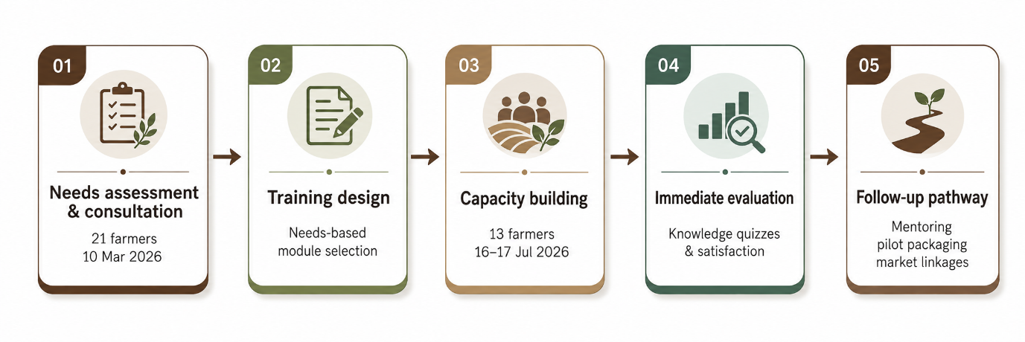
Figure 1. Needs-based implementation pathway developed from the original project chronology and participant numbers.
Methodology
Study design and setting
This study employed a descriptive community engagement design to document the implementation and immediate outcomes of an international capacity-building initiative for coffee farmers in Patikul, Sulu, Philippines. The initiative was conducted through collaboration between Universitas Muhammadiyah Yogyakarta (UMY), Indonesia, and Sulu State University (SSU), Philippines. It involved the Federation of Sulu Coffee Industry Cooperative, the Kabbun Takas Coffee Farmers Association, coffee farmers from Barangay Kabbun Takas and Barangay Bacong, the Provincial Agriculture Office, and the Provincial Tourism Office. The project adopted a needs-based and participatory approach. This approach positioned farmers and local stakeholders as active contributors to the identification of problems, prioritization of training needs, and development of contextually appropriate responses. Participatory approaches are valuable in agricultural extension because they shift knowledge sharing beyond a top-down model and encourage farmers’ involvement in problem-solving, learning, and local innovation [8], [9]. The project consisted of two connected phases: a community needs assessment and consultation, followed by a two-day capacity-building program.
Phase 1: Community needs assessment
The first phase was conducted on 10 March 2026 at Sulu State University. The activity served as the project’s initial consultation and needs assessment involving representatives of coffee-farming communities, university personnel, farmer organizations, and relevant stakeholders. The program included an introduction to the UMY–SSU collaboration, a presentation of the project rationale and objectives, focus group discussions, a training needs assessment survey, commitment sharing, and a discussion of possible follow-up actions. A structured survey was administered to identify farmers’ demographic characteristics, coffee-farm profiles, coffee varieties, sources of seedlings, cultivation practices, harvesting methods, post-harvest activities, packaging practices, marketing channels, and perceived challenges. The survey also identified priority forms of support and training required by the farmers. A total of 21 coffee farmers completed the needs assessment survey. The results were analyzed descriptively using frequencies and narrative synthesis to identify recurrent constraints and priority training areas. Focus group discussions complemented the survey data by allowing participants to explain the challenges that they encountered in coffee farming, harvesting, post-harvest handling, branding, packaging, and marketing. This combination of survey and discussion enabled the project team to identify not only measurable characteristics of the target group but also the local experiences underlying their reported needs. Participatory assessment and co-design approaches are useful because they allow interventions to be shaped by community knowledge and context rather than by external assumptions [9], [10].
Phase 2: Capacity-building program
The second phase was conducted on 16–17 July 2026 at Sulu State University. The two-day program was developed based on the needs identified during the first phase. It covered four thematic areas: coffee farming from nursery establishment to post-harvest processing; vermicomposting as an organic fertilizer technology; coffee branding and marketing; and participatory coffee-packaging design. The first day covered vermicomposting, a visit to the vermiculture facility at the SSU Agricultural School, coffee branding and marketing, and a group brainstorming workshop on packaging concepts. The facility visit enabled participants to observe vermiculture processes, including bed preparation, worm management, and vermicast harvesting. The packaging workshop asked participants to identify desirable elements for a Kahawa Sug coffee package. Ideas developed by the participants included a 250 g package size, 100% Robusta coffee, medium roast, earth-tone colors, the Kahawa Sug brand, visual references to the vinta and Sulu landscape, and local textile motifs. These collective ideas informed an AI-assisted conceptual packaging prototype.
The second day focused on coffee nursery establishment, seedling propagation, planting, crop maintenance, fertilization, organic farming practices, harvesting, drying, grading, storage, and basic coffee-processing principles. Resource persons from the Provincial Agriculture Office and other partners delivered the technical sessions. The program used lectures, facilitated discussion, field exposure, and participatory workshops, combining information transfer with experiential learning. The alignment between the identified needs of the coffee farmers and the corresponding components of the capacity-building program is presented in Table 1.
Table 1. Alignment between identified needs and program components
Needs identified | Capacity-building response | Expected immediate contribution
Limited seedling quality and cultivation knowledge | Nursery, propagation, planting, maintenance, fertilization | Improved technical understanding and clearer farm-management priorities
Post-harvest handling constraints | Harvesting, drying, grading, storage, processing principles | Better awareness of quality-preserving practices
High fertilizer costs / organic input needs | Vermicomposting lecture + vermiculture facility visit | Exposure to locally applicable organic-input technology
Weak branding, packaging and market access | Branding, marketing, participatory packaging workshop | Initial product identity, market orientation, and packaging concept

Evaluation and data analysis
Immediate learning outcomes were assessed using pre-test and post-test knowledge quizzes administered before and after the capacity-building sessions. The assessment covered vermicomposting and coffee-farming topics. Thirteen participants completed both the pre-test and post-test assessments. The paired scores were analyzed using the Wilcoxon signed-rank test because of the small sample size and the ordinal, non-parametric nature of the test-score data. Effect sizes were calculated to indicate the magnitude of observed change. Participants also completed a post-training evaluation questionnaire assessing overall satisfaction, presenter effectiveness, usefulness of the content, encouragement of participation, adequacy of topics, presenter knowledge, and adequacy of the training facility. Responses were summarized descriptively using frequencies. Qualitative comments and observations gathered during the training were used to contextualize the quantitative findings.
The vermicomposting assessment focused on concepts presented in the lecture and facility visit, including bed preparation, worm management, and vermicast harvesting. The coffee-farming assessment covered the technical content delivered during the program, including nursery establishment, seedling propagation, planting, crop maintenance, fertilization, harvesting, drying, grading, storage, and basic processing principles. For transparency, the paired analysis is reported using the Wilcoxon signed-rank statistic (W), the p-value, and the effect-size coefficient (r) in Table 2.
The evaluation was designed to assess immediate learning and participant perceptions rather than long-term effects on farming practices, coffee yield, product quality, or household income. The results should therefore be interpreted as evidence of early-stage engagement and capacity-building outcomes, not as proof of long-term livelihood impact. This cautious interpretation is consistent with broader farmer-learning research, which recommends evaluating agricultural training beyond immediate knowledge scores by tracking adoption, livelihood-related changes, and learning over time.
Ethical considerations
Participation in the needs assessment, knowledge quizzes, and training evaluation was voluntary. Participants received information about the purpose of the activity, the nature of the data collected, and the confidentiality of their responses before participating. The project obtained ethical clearance from the Directorate of Research and Community Engagement of Universitas Muhammadiyah Yogyakarta under Approval No. 432/LD.3-III/DRP/IV/2026. All findings are reported in aggregated form to protect the identity of individual participants.

Results and Discussion
Profile and needs of coffee farmers
The needs assessment involved 21 coffee farmers from several communities in Patikul, Sulu. All survey respondents were male, and their ages ranged from 22 to 76 years. The largest age group comprised farmers older than 52 years, while only four respondents were aged 22–27 years. Most respondents were from Barangay Bacong and Barangay Kabbun Takas; the remainder came from Bangkalan, Darayan, Latih, or did not indicate their village. Coffee production was predominantly small-scale and family-based. Most respondents operated farms ranging from 0.5 to 2 hectares, although a small number managed larger areas. Coffee farming in the study sites had been revitalized only recently after many households returned to their communities and resumed agricultural activities. Fourteen respondents reported coffee trees younger than two years, while only five reported trees older than ten years. This finding indicates that many farms were still in the early stages of rehabilitation or expansion, which helps explain the limited harvests and low income derived from coffee.
Robusta was the dominant coffee type cultivated by participating farmers. Twelve respondents planted Robusta only, while others cultivated Robusta in combination with Arabica, Excelsa, and/or Liberica. Twelve farmers depended on self-propagated seedlings, whereas the remainder obtained seedlings from government programs, commercial sources, or wild stocks. Dependence on self-propagated and uncertified planting materials indicates constrained access to reliable, high-quality seedlings, a problem also observed in the wider Sulu coffee value chain [2]. The distribution of coffee types cultivated by participating farmers and their main seedling sources, highlighting the dominance of Robusta and the reliance on self-propagated planting materials, can be seen in Figure 2.
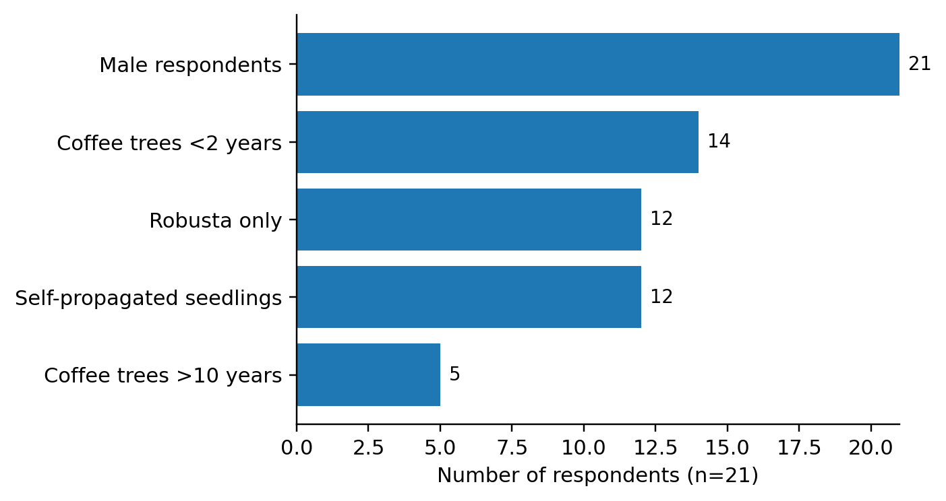
Figure 2. Selected respondent characteristics for which explicit counts are reported in the original draft (n=21)
The needs assessment revealed constraints throughout the coffee value chain. At the production stage, farmers reported thin or slow-growing coffee trees, inadequate farming tools, limited access to quality seedlings, pests and diseases, limited capital for farm improvement, and insufficient technical knowledge of cultivation practices. Several participants associated taller coffee trees with higher yields and therefore allowed trees to grow without regular pruning. This practice made harvesting more difficult and reduced the efficiency of routine farm management.
Farmers also reported challenges during harvesting and post-harvest handling. Harvesting was generally undertaken manually, and the absence of suitable tools increased the labor required, especially for excessively tall trees. Participants described limited knowledge of selective harvesting of ripe cherries, drying, processing, grading, and storage. Poor farm-to-market road access further raised transportation costs and restricted farmers’ capacity to bring fresh cherries or processed products to broader markets. These findings supported the inclusion of coffee nursery establishment, crop maintenance, harvesting, and post-harvest management in the capacity-building program.
Beyond production constraints, participants identified organic fertilizer, coffee quality improvement, packaging, branding, and marketing as priority areas for support. Interest in vermicomposting reflected the high cost of inorganic fertilizer and the search for more affordable, locally applicable organic-input options. Farmers also perceived that improved packaging and branding could strengthen the marketability of Kahawa Sug, particularly if coffee products were sold outside local markets. These needs demonstrate that farmer support should address the whole value chain rather than concentrate only on on-farm production.
This pattern is consistent with recent coffee value-chain research showing that value addition, processing, branding, packaging, and stronger farmer participation in upstream market functions are often limited among smallholders, even where cooperative structures exist.¹³ Philippine coffee research also highlights the need to combine infrastructure and skills development with more connected and adaptive market systems [11].
Implementation of capacity building
Based on the needs assessment, UMY and SSU implemented a two-day capacity-building program on 16–17 July 2026. Thirteen coffee farmers, comprising 12 men and one woman, participated in the full program. The activity addressed coffee production, organic fertilizer through vermicomposting, coffee branding and marketing, and participatory packaging design. The vermicomposting component combined a lecture with a visit to the SSU Agricultural School’s vermiculture facility. Participants observed bed preparation, worm management, and vermicast harvesting. This activity allowed farmers to link classroom content with visible production processes and potential on-farm application. The coffee-farming sessions addressed nursery establishment, seedling propagation, planting, fertilization, crop maintenance, harvesting, post-harvest handling, drying, grading, storage, roasting principles, and quality control.
The branding and marketing session introduced product identity, market positioning, consumer-oriented packaging, and storytelling as components of coffee value addition. Farmers were encouraged to consider local consumers, tourists, specialty coffee shops, institutional buyers, trade fairs, and online markets as potential market segments. The session emphasized that a coffee product’s market value depends not only on its physical quality but also on clear product information, credible origin claims, and an identity that distinguishes it from competing products. Packaging can influence consumers’ perceptions and purchasing interest, particularly when it communicates product quality and a distinctive local identity [3].
The inclusion of vermicomposting is also supported by evidence that technical training can increase farmers’ willingness and capacity to adopt organic fertilizers, although adoption depends on differences in farm resources, farmer characteristics, and the accessibility of practical guidance [14]. Studies of on-farm vermicomposting further identify training as an important driver while noting barriers such as initial investment, infrastructure, and farmers’ short-term risk considerations [15]. From an agronomic perspective, vermicompost is widely recognized as a nutrient-rich biofertilizer with potential benefits for soil quality, crop performance, and sustainable organic-waste management [16], [17].
Participatory packaging concept
The packaging workshop involved group brainstorming on a market-oriented identity for Kahawa Sug. Participants converged on a 250 g package containing 100% Robusta coffee with a medium-roast profile. They also proposed green and brown earth tones to reflect Sulu’s agricultural landscape, along with product information and visual elements that represent local culture. The proposed visual identity incorporated the vinta, Sulu syabit textile motifs, mountain scenery, and a rising-sun image. These elements were selected because they represent local cultural identity and the social meaning of coffee production in Sulu. The ideas generated through the workshop were consolidated into an AI-assisted conceptual packaging prototype, presented in Figure 3. The prototype should be interpreted as an initial co-design output, not a commercially tested product. Its printing, distribution, market testing, and consumer evaluation were beyond the project’s available time and budget.

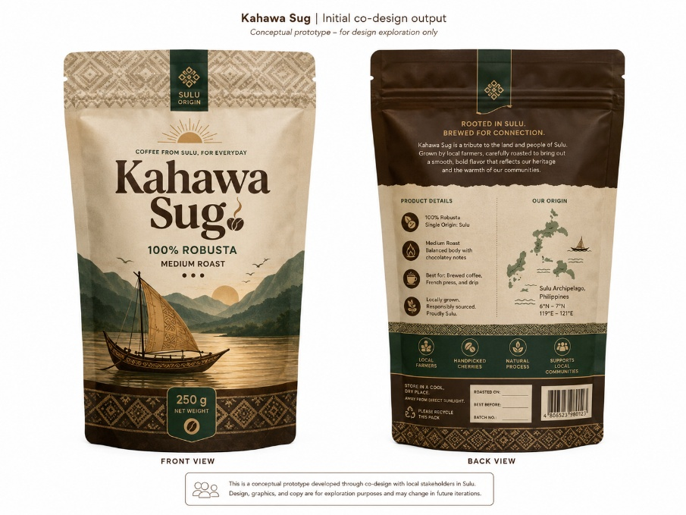
Figure 3. Participatory coffee packaging concept for Kahawa Sug, incorporating the vinta, local textile motifs, Sulu landscape, and product information proposed during the co-design workshop
The conceptual packaging output illustrates the value of participatory design in community engagement. Instead of importing a product identity, the process enabled participants to articulate cultural symbols, desired product characteristics, and market aspirations. This approach may strengthen ownership of future product-development activities, although its commercial feasibility still requires technical review, food-label compliance assessment, production-cost analysis, and market testing.
The literature on coffee and local-product packaging supports this emphasis on visual identity and cultural grounding. Research on Gayo Arabica coffee identifies color, form, brand, illustration, labeling information, and local-cultural elements as important dimensions in packaging visualization [10]. Work with indigenous-community food products similarly shows that culturally representative design elements can shape consumer impressions and function as a vehicle for communicating community identity [18], [19].
Immediate learning outcomes
Thirteen participants completed the pre-test and post-test assessments for vermicomposting and coffee farming. Individual scores showed mixed patterns: some participants improved after the training, while others recorded identical or lower scores. For vermicomposting, the Wilcoxon signed-rank test produced W = 27.5, p = 1.00, and r = 0.02, indicating no statistically significant immediate change and a negligible effect. For coffee farming, the test produced W = 14.0, p = 0.62, and r = 0.22, indicating no statistically significant immediate change and a small effect. The immediate learning outcomes of the capacity-building program, including the pre-test and post-test results for vermicomposting and coffee-farming knowledge, can be seen in Table 2.

Table 2. Immediate learning outcomes of capacity-building participants
Training component | Statistical test | $p$-value | Effect size | Interpretation
Vermicomposting | $$W=27.5$$ | 1.00 | $$r=0.02$$ | No statistically significant immediate change; negligible effect
Coffee farming | $$W=14.0$$ | 0.62 | $$r=0.22$$ | No statistically significant immediate change; small effect

These results should not be interpreted as evidence that the training had no value. First, the small sample size limited statistical power. Second, the assessment was administered immediately after a short intervention, which limited the opportunity for participants to practice, consolidate, and demonstrate new knowledge. Third, the written instrument was administered in Filipino, whereas Tausug was the primary language of most participants. Differences in language proficiency, literacy, and formal educational background may therefore have influenced test performance independently of actual learning.
The results also highlight the limits of relying exclusively on written knowledge tests in community-based agricultural training. Experiential components, such as the vermiculture-facility visit, may strengthen practical understanding and confidence but may not be fully captured through short written assessments. Future evaluation should combine translated or orally administered tests with demonstration-based assessment, farm observation, follow-up mentoring, and monitoring of practice adoption.
Farmer-field-school evaluation literature reinforces this distinction between immediate learning scores and longer-term adoption. Monitoring frameworks that combine focus-group reflection, direct observation, and practice-adoption indicators can provide a more complete view of how farmer learning translates into action.¹⁷
Participant evaluation and implementation lessons
Despite limited measured knowledge gains, participant feedback showed strong satisfaction with the training. Eight of 13 participants rated their overall satisfaction at the highest level, while eight rated the content as useful at the highest level. Most participants also rated the presenters, participation opportunities, topic adequacy, and training facility positively.
The participant evaluation ratings, which indicate strong satisfaction with the training despite limited measured knowledge gains, can be seen in Figure 4 and Table 3.
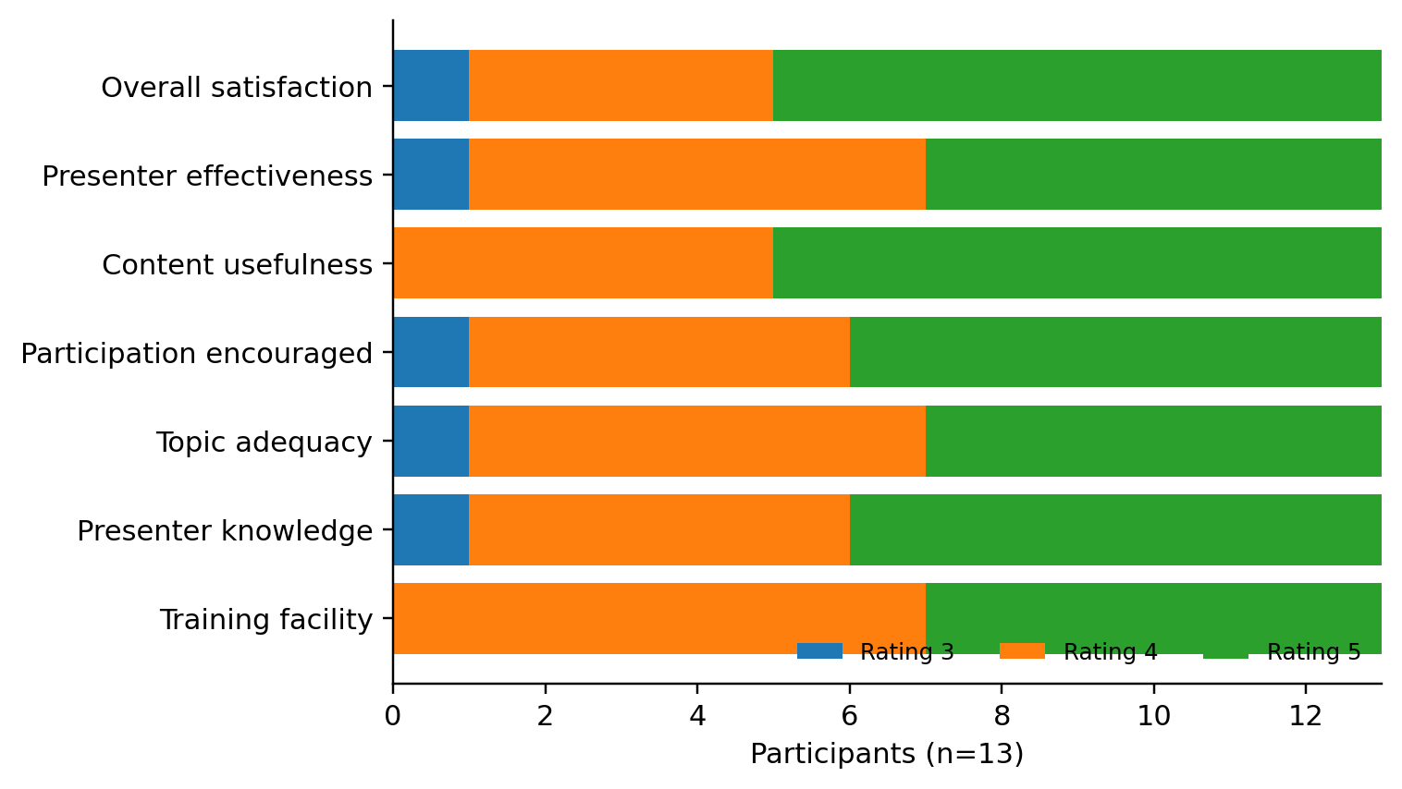
Figure 4. Participant evaluation ratings reported in the original draft (n=13).

Table 3. Participant evaluation of the capacity-building program
Evaluation item | Rating 3 | Rating 4 | Rating 5
Overall satisfaction with the training | 1 | 4 | 8
Overall presenters’ effectiveness | 1 | 6 | 6
Training content was useful | 0 | 5 | 8
Participation was encouraged | 1 | 5 | 7
Topics discussed were adequate | 1 | 6 | 6
Presenters were knowledgeable | 1 | 5 | 7
Training facility was adequate | 0 | 7 | 6
Vermicomposting was frequently identified as one of the most beneficial components, followed by coffee processing. This feedback suggests that farmers placed high value on practical and directly applicable technologies. Participants also recommended further training, particularly on coffee marketing, and some expressed interest in a benchmarking visit to Indonesia to observe coffee production and processing practices. The project achieved important early-stage outcomes: it engaged farmers and local stakeholders, generated an evidence-based training agenda, delivered capacity-building activities, and produced a participatory concept for Kahawa Sug packaging. However, several planned outputs were not completed. Printed information, education, and communication materials were not distributed, and the intended large-scale production and pilot testing of packaging prototypes did not take place because of budgetary and logistical limitations.
In this study, farmer empowerment is therefore interpreted as an early-stage capacity-building process rather than a demonstrated socioeconomic outcome. Evidence of this process includes farmers’ participation in identifying priority needs, their contribution to the Kahawa Sug packaging co-design, exposure to locally applicable production and organic-input practices, and the strengthening of institutional linkages for follow-up support. Because the project did not measure post-program changes in decision-making autonomy, collective action, technology adoption, productivity, market access, or income, no claim is made that empowerment was achieved in these longer-term dimensions.
These outcomes demonstrate that needs-based international community engagement can generate relevant interventions and foster institutional collaboration even within a limited implementation period. Yet, the project also confirms that short-term training cannot by itself produce measurable changes in farming practices, value-chain performance, or income. Sustained engagement through mentoring, demonstration activities, localized learning materials, packaging refinement, and longitudinal evaluation will be needed to translate initial learning and partnership-building into longer-term outcomes. The need for continued engagement is also consistent with participatory coffee value-chain research, where tangible product and organizational improvements emerged through repeated interaction among farmers, researchers, and market actors rather than from a single training event [12]. University–community co-learning studies similarly emphasize mutual commitment, co-creation, and ongoing relationships as conditions for turning knowledge exchange into usable local innovation [20]. The literature-supported follow-up priorities for strengthening the continuity and long-term impact of the community engagement initiative can be seen in Table 4 and Figure 5.
Table 4. Literature-supported follow-up priorities added to strengthen the discussion
Follow-up priority | Rationale from project findings | Supporting literature
Farm-based mentoring and demonstrations | Immediate tests were inconclusive; farmers valued practical learning | Farmer learning should be monitored through practice adoption and observation [17]
Vermicomposting pilots | High fertilizer cost and interest in organic inputs | Training supports organic-fertilizer adoption, but infrastructure and investment barriers remain [14]–[16]
Packaging refinement and market testing | Concept exists but is not yet commercially validated | Packaging quality, labeling and local-cultural identity shape product communication [18], [19]
Market and cooperative linkages | Farmers face market-access and value-addition constraints | Coffee value-chain participation and coordinated market functions are important for smallholders [11]–[13]
Long-term university–community partnership | Short project duration limits sustained outcomes | Co-learning and shared commitment strengthen community-engagement outcomes [20]

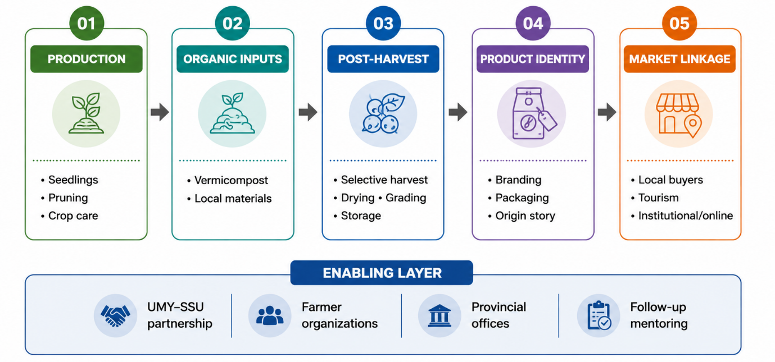
Figure 5. Proposed follow-up pathway for strengthening the Kahawa Sug value chain based on the original project findings
Conclusion
This initiative produced three immediate achievements in Patikul, Sulu: (1) a needs assessment that identified constraints in seedlings, cultivation and post-harvest practices, organic inputs, branding, packaging, and market access; (2) a two-day capacity-building program for 13 farmers covering coffee production, vermicomposting, branding, marketing, and participatory design; and (3) an initial Kahawa Sug packaging concept grounded in Sulu cultural elements. The pre-test/post-test analysis did not show statistically significant immediate knowledge gains, although participant evaluations were highly positive. Accordingly, the initiative should be interpreted as an early-stage capacity-building and partnership platform rather than evidence of improved productivity or income. Future work should prioritize farm-based mentoring, Tausug-language learning materials, packaging refinement and market testing, stronger market linkages, and longer-term monitoring of practice adoption, product quality, productivity, and income.

Acknowledgements
The authors gratefully acknowledge Universitas Muhammadiyah Yogyakarta and Sulu State University for their institutional and financial support for this international community engagement initiative. The authors also thank the Federation of Sulu Coffee Industry Cooperative, the Kabbun Takas Coffee Farmers Association, coffee farmers from Barangay Kabbun Takas and Barangay Bacong, the Provincial Agriculture Office, the Provincial Tourism Office, resource persons, and all participants who contributed their time, knowledge, and experiences to the project.

References
[1] Z. Awing, “Brewing peace and reviving Sulu’s coffee industry,” People in Need, 2024. [Online]. Available: https://www.peopleinneed.net/brewing-peace-and-reviving-sulus-coffee-industry-11769gp
[2] People in Need Philippines, Maranao People Development Center, Inc., and United Youth of the Philippines—Women, Inc., Assessing the Coffee Value Chain in Basilan and Sulu: Market Insights, Feasibility, Gaps. BAEP-LEAP Consortium, 2025. [Online]. Available: https://philippines.peopleinneed.net/en/assessing-the-coffee-value-chain-in-basilan-and-sulu-market-insights-feasibility-gaps-2624pub
[3] A. A. Mabalay, “Enhancing social enterprise coffee marketability through sensory packaging: Consumer impressions, willingness to buy, and gender differences,” Asia Pacific Journal of Marketing and Logistics, vol. 36, pp. 3236–3254, 2024, doi: 10.1108/APJML-01-2024-0098.
[4] H. Ravaghi, A.-L. Guisset, S. Elfeky, N. Nasir, S. Khani, E. Ahmadnezhad, and Z. Abdi, “A scoping review of community health needs and assets assessment: Concepts, rationale, tools and uses,” BMC Health Services Research, vol. 23, Art. no. 44, 2023, doi: 10.1186/s12913-022-08983-3.
[5] SERD Personnel Editor, “Coop for a cup: Role of cooperatives in coffee technology adoption,” Philippine Council for Agriculture, Aquatic and Natural Resources Research and Development (PCAARRD), 2023. [Online]. Available: https://ispweb.pcaarrd.dost.gov.ph/coop-for-a-cup-role-of-cooperatives-in-coffee-technology-adoption/
[6] A. Haryono, I. Juniarti, K. Matajat, A. I. Suroso, and M. Soesilo, “Partnership development of smallholder coffee cultivation: A model for social capital in the global value chain,” Economies, vol. 12, Art. no. 349, 2024, doi: 10.3390/economies12120349.
[7] W. J. Barbon, C. Myae, R. Vidallo, P. S. Thant, E. Monville-Oro, and J. Gonsalves, “Applying participatory action research methods in community-based adaptation with smallholders in Myanmar,” Frontiers in Climate, vol. 3, Art. no. 734053, 2021, doi: 10.3389/fclim.2021.734053.
[8] R. Vidyawati, S. P. Singh, and R. S. Jadoun, “Participatory agricultural extension: A catalyst for sustainability and farmer empowerment,” International Journal of Agricultural Extension and Social Development, vol. 8, pp. 333–341, 2025.
[9] M. M. Hossain, S. Islam, M. I. Ali, and M. Rahimi, “Assessing the potential and limitations of organic farming for sustainable agriculture in Bangladesh,” Environmental Challenges, vol. 21, Art. no. 101346, 2025, doi: 10.1016/j.envc.2025.101346.
[10] P. Nemenzo-Calica, H. Pateño-Bongas, M. O. G. Magallones, and M. B. Clapano, “Sustainability in small-scale coffee farming: Agricultural practices, women’s role, and climate change adaptation along the buffer zone of Mt. Hamiguitan, Davao Oriental, Philippines,” Sustainability, vol. 18, Art. no. 34, 2026, doi: 10.3390/su18010034.
[11] E. K. Opoku, M.-J. S. Wang, S. Guevarra, M. Bazylewich, and A. Tham, “Envisioning digitalised value chains in the aftermath of COVID-19: A case study of Philippine coffee,” Journal of Agribusiness in Developing and Emerging Economies, vol. 13, no. 5, pp. 797–811, 2023, doi: 10.1108/JADEE-12-2021-0315.
[12] J. Jacobi et al., “Making specialty coffee and coffee-cherry value chains work for family farmers’ livelihoods: A participatory action research approach,” World Development Perspectives, vol. 33, Art. no. 100551, 2024, doi: 10.1016/j.wdp.2023.100551.
[13] D. M. Wambua, S. N. Ndirangu, H. Mogaka, B. M. Gichimu, and X. Xiao, “Decomposition of the coffee value chain among smallholder farmers in Embu and Kirinyaga Counties in Central Kenya,” Advances in Agriculture, vol. 2024, Art. no. 9346391, 2024, doi: 10.1155/2024/9346391.
[14] Y. Liu, K. Shi, Z. Liu, L. Qiu, Y. Wang, H. Liu, and X. Fu, “The effect of technical training provided by agricultural cooperatives on farmers’ adoption of organic fertilizers in China: Based on the mediation role of ability and perception,” International Journal of Environmental Research and Public Health, vol. 19, no. 21, Art. no. 14277, 2022, doi: 10.3390/ijerph192114277.
[15] H. Rastegari, M. Nooripoor, M. Sharifzadeh, and D. C. Petrescu, “Drivers and barriers in farmers’ adoption of vermicomposting as keys for sustainable agricultural waste management,” International Journal of Agricultural Sustainability, vol. 21, no. 1, Art. no. 2230826, 2023, doi: 10.1080/14735903.2023.2230826.
[16] D. D. Mohite et al., “Vermicomposting: A holistic approach for sustainable crop production, nutrient-rich bio fertilizer, and environmental restoration,” Discover Sustainability, vol. 5, Art. no. 60, 2024, doi: 10.1007/s43621-024-00245-y.
[17] H. van den Berg et al., “Monitoring, evaluation and learning (MEL) in farmer field schools on food security and adaptation to climate change: Pilot testing of a framework in Malawi,” Food Security, vol. 15, pp. 1611–1627, 2023, doi: 10.1007/s12571-023-01386-0.
[18] R. Fadhil, D. Nurba, K. Rizal, D. Dahlan, and S. Mahdi, “Strategi pengembangan visualisasi desain kemasan kopi Arabika Gayo untuk meningkatkan preferensi minat konsumen,” Jurnal Teknologi Industri Pertanian, vol. 32, no. 3, pp. 229–238, 2022, doi: 10.24961/j.tek.ind.pert.2022.32.3.229.
[19] M. Widyarini, T. A. Philemon, and E. Simatupang, “Packaging design elements and consumers impressions: A context in local food branding and communication of indigenous community in Indonesia,” in Proc. 3rd Borobudur International Symposium on Humanities and Social Science 2021, 2022, pp. 503–507, doi: 10.2991/978-2-494069-49-7_83.
[20] A. Habiyaremye, “Co-learning in university-community engagement for sustainable local food systems in South Africa,” Humanities and Social Sciences Communications, vol. 10, Art. no. 820, 2023, doi: 10.1057/s41599-023-02350-1.

