Solution And Visualization 3D Plane Inverse Kinematics Method

Goldberd Harmuda Duva Sinaga^{1*}, Ruben Cornelius Siagian² , Lulut Alfaris³, Pandu Pribadi⁴, Arip Nurahman⁵

*e-mail: rubensiagian775@gmail.com, lulut.alfaris@pkpp.ac.id, Goldberhdsinaga@gmail.com, pandupribadi2384@gmail.com , aripnurahman@institutpendidikan.ac.id.

¹Physics Education, HKBP Nommensen University, Medan, North Sumatera, Indonesian,
²Physics Departemen, Faculty Mathematics Science and Education, Medan State University, Medan, North Sumatera, Indonesian,
³Physics education, STIT Muhammadiyah Banjar, Indonesian,
⁴Department of Science education, Indonesian education university, Bandung, West Java, Indonesian.

ABSTRACT
The hyper-redundant type of robot is a type of robot that in carrying out its duties in the field of kinematics its degrees of freedom exceed the required minimum degrees. The advantage will be increased capability in operation and performance, if the degrees of freedom are excessive, even in unorganized and complex systems and environments. Algebraic approach method in inverse kinematics algorithm analysis can use; analytic algebra, jacobian basis, analytic KI, exponential multiplication, grobner, and conformal geometry. Iterative approach method in inverse kinematics algorithm analysis can use; genetic algorithm, fuzzy logic, ANFIS, and evolutionary algorithm. The geometric approach method in the inverse kinematics algorithm analysis can use; capital method. The purpose of this study is to analyze a virtual 2 arm robot, which will use axis manipulation in three dimensions using an inverse kinematics solution, using a geometric approach. How to step along on the z axis by rotating and using the reverse kinematics solution to the desired location. The visualization results will be repeated so as to ensure the effectiveness of the algorithm. As for this algorithm will provide a single solution, and this algorithm will prevent and reduce singularities if the link is lower.
Keywords: Robot arm analiysis, hyper-redundant robot, Mathlab software
ABSTRAK

Robot jenis hyper-redundant adalah jenis robot yang dalam menjalankan tugasnya di bidang kinematika derajat kebebasannya melebihi derajat minimum yang dipersyaratkan. Keuntungan akan meningkatkan kemampuan dalam operasi dan kinerja, jika derajat kebebasannya berlebihan, bahkan dalam sistem dan lingkungan yang tidak terorganisir dan kompleks. Metode pendekatan aljabar dalam analisis algoritma kinematika terbalik dapat menggunakan; aljabar analitik, basis jacobian, KI analitik, perkalian eksponensial, grobner, dan geometri konformal. Metode pendekatan iteratif dalam analisis algoritma kinematika invers dapat menggunakan; algoritma genetika, logika fuzzy, ANFIS, dan algoritma evolusioner. Metode pendekatan geometrik dalam analisis algoritma kinematika terbalik dapat menggunakan; metode modal. Tujuan dari penelitian ini adalah untuk menganalisis robot 2 lengan secara virtual, yang akan menggunakan manipulasi sumbu dalam tiga dimensi menggunakan solusi kinematika terbalik, dengan menggunakan pendekatan geometris. Bagaimana langkah bersama pada sumbu z dengan memutar dan menggunakan solusi kinematika terbalik ke lokasi yang diinginkan. Hasil visualisasi akan diulangi sehingga dapat menjamin efektivitas algoritma. Adapun algoritma ini akan memberikan solusi tunggal, dan algoritma ini akan mencegah dan mengurangi singularitas jika linknya lebih rendah.
Kata Kunci: Analisis lengan robot, robot hiper-redundan, perangkat lunak Mathlab

INTRODUCTION

The hyper-redundant type of robot is a type of robot that in operating its duties in kinematics its degrees of freedom exceed the minimum required degrees (Chirikjian & Burdick, 1994). The advantages of this will increase an ability in operation and performance, if the degrees of freedom are excessive, even in an unorganized and complex system and environment (Harbourne & Stergiou, 2009). This type is very useful in various fields of science, for example, such as; military and industrial sectors.
In applications, such as emergencies, this type of robot can be applied effectively, because it can also regulate; cleaning the wrong and dirty things in the engine, inspection of road connections, inspection of space shuttles, as well as nuclear power plants. Then a workflow, or algorithm in the robot is needed which aims to ensure the accuracy, and efficacy of the system to be run (Guo et al., 2017). The type of inverse kinematics algorithm is an algorithm to be tested, this algorithm is very important in analyzing robot control, because it can analyze redundant manipulators, and can determine the final position and orientation of the effector, but an important factor is needed in this analysis, namely the variables needed actuator (Nearchou, 1998). The inverse kinematics method can be classified based on the method, namely, among others; iterative approach, geometric approach, and algebraic approach (Tejomurtula & Kak, 1999).
The algebraic approach method in the analysis of inverse kinematics algorithms (Wei et al., 2014) can use; analytical algebra, jacobian basis, analytical KI, exponential multiplication, grobner, and conformal geometry. The iterative approach method in inverse kinematics algorithm analysis (Manseur & Doty, 1988) can use; genetic algorithms, fuzzy logic, ANFIS, and evolutionary algorithms. The method of geometric approach in the analysis of the inverse kinematics algorithm can use; capital method (Zamanzadeh & Ahmadi, 2021).
Unfortunately the computational burden will be heavy if using symbolic expansion (Sessler & Jondral, 2005), in the algebraic approach, the other drawback is that there is no clear indication in the optimal solution (Parrilo, 2003), even though in different arm configurations there are several potential solutions (Noor et al., 2020). However, the computation time will be more significant if using an iterative method, but if it comes to the inverse kinematics solution it will take a long time (Beeson & Ames, 2015). so to take the unique manipulator structure to find the angle can use the geometric heuristic on the geometric approximation (Chirikjian & Burdick, 1994), which will give a direct solution.
The purpose of this study is to analyze a 2-arm robot virtually (Pierrot et al., 1999), which will use axis manipulation in three dimensions using an inverse kinematics solution, using a geometric approach (Mohamed et al., 2009).
RESEARCH METHOD

The algebraic approach method in the analysis of inverse kinematics algorithms (Wei et al., 2014) can use; analytical algebra, jacobian basis, analytical KI, exponential multiplication, grobner, and conformal geometry. The iterative approach method in inverse kinematics algorithm analysis can use (Samarakoon et al., 2021); genetic algorithms, fuzzy logic, ANFIS, and evolutionary algorithms. The method of geometric approach in the analysis of the inverse kinematics algorithm can use; capital method (UE, n.d.).

RESULT AND DISCUSSION
We can review the positive and negative directions (Faumont et al., 2011), on the z-axis in 4 different quadrants in the simulated target position (Barnsley et al., 2016). We'll be doing a visualization on a fixed link length (Albrecht-Buehler et al., 2005). Based on the picture above, we see that the first square will show the final effect on the positive z-axis with length (Hu & Sonnerup, 2002) (2,1,1). By plotting with a unit length of 1, we will get (2,1,1) as the final position of the effector. While (5.5, 4.3, 2) is the final position of the effector at the eight elbow. With a unit length of half, at the elbow of 16 we get (3, 4, 1), and (3, 2, 1) is the location of the final effector of length 1 , at the elbow it is 4.

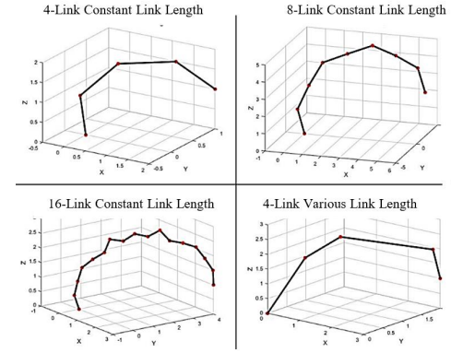
Figure 5. Simulation on positive z
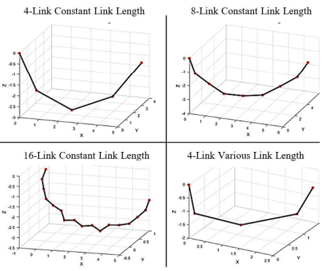
Figure 6. Simulation on negative z.

The picture above describes and visualizes the results of the algorithm from the negative z-axis (Woods et al., 1993). The location of the effector is at (5, 3, -1) on the 4th elbow. While at the 8th elbow the final position of the effector (Merad et al., 2020) is (6, 4.2, -1) with the unit length being one. The position of the effector (5, 1, -2) with the unit length is 0.5 at the elbow 16, and we can see that there is also the position of the effector at the position (2.5, 1.3, -0.5) with various units of length, namely; (1.1, 1.2, 1.3, and 1) on the elbows of 4 robots HRR. From the picture above, we can see that both negative and positive quadrants can be implemented in 3-dimensional space (Bostan et al., 2016). Simulations performed from various elbows also accommodate down and up elbow configurations. In the test, it also consistently formed coils at elbows 4 and 8 on the HRR (Rosheim, 1994).

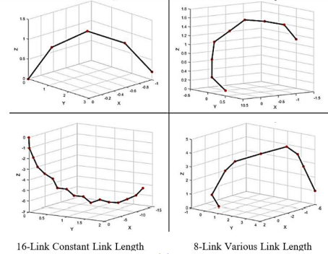
Figure 7. The final position of the effector is in quadrant 2, on the positive z-axis
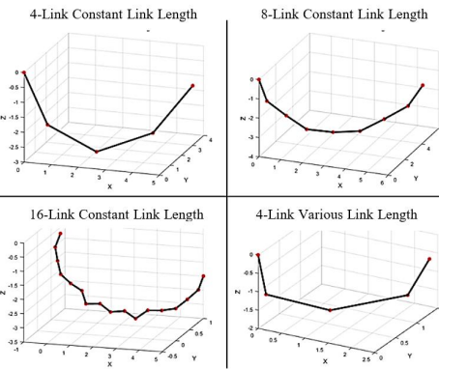
Figure 8. The final position of the effector in quadrant 1, on the negative z-axis

However, we can see that only part of the support at the end of the HRR elbow is at elbow 16. And the elbow lengths of 16 and 8 are still more or less better than elbow lengths of 4 and 8 (Anakwe et al., 2011). This is due to the zigzag shape of links 8 and 16, so that it is possible not to reach the final effector location, and this will not prevent the singularity from occurring (Aristidou et al., 2018). To make the HRR have a 2-m link count, the link must be forced to lock in the simulation with another link (Chen, 2007), because there are things that will not be used in the calculation, namely links that are not 2-m (Lü & Zhou, 2011).

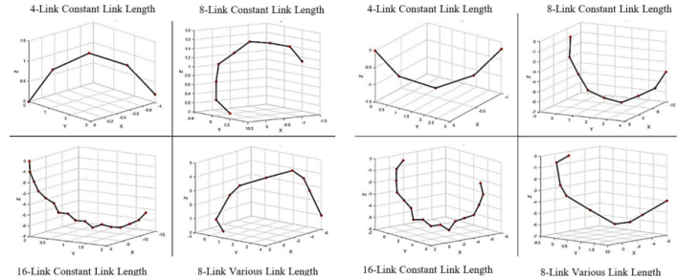

Figure 9. The final position of the effector in the 2 quadrant

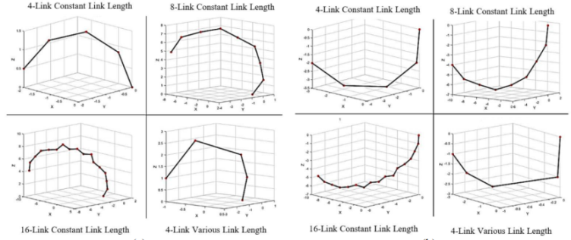

Figure 10. The final position of the effector in the 3 quadrant

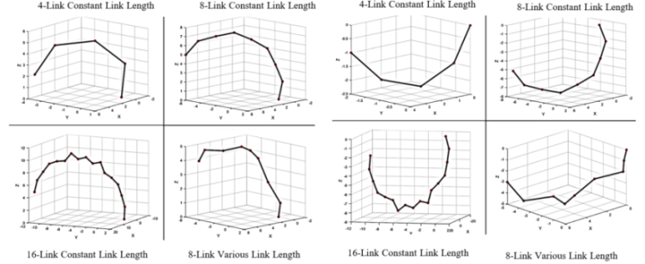

Figure 11. The final position of the effector in the 4 quadrant

The 4th corner of the HRR will change due to a locking link from the 5th corner of the HRR and will be one link larger than before (Knez & Camerer, 1994). As for this algorithm, it will provide a single solution because usually algorithms that usually require many solutions (Deb, 2003), and the other advantage is that this algorithm will prevent and reduce singularity if the link is lower (Levy & Lindenbaum, 1998).

CONCLUSSION

Based on previous research, algorithm studies for 2 dimensions have been carried out, so in this article a study of algorithms for 3 dimensions has been carried out, which is the development of previous research. We have shown how to step together on the z-axis by rotating and using the inverse kinematics solution to the desired location. The tool in simulating this algorithm simulation is using the mathlab tool. The results of the visualization will be repeated so that it can ensure the effectiveness of the algorithm. As for this algorithm, it will provide a single solution because usually algorithms that usually require many solutions, and the other advantage is that this algorithm will prevent and reduce singularity if the link is lower.

REFERENCE

Albrecht-Buehler, C., Watson, B., & Shamma, D. A. (2005). Visualizing live text streams using motion and temporal pooling. IEEE Computer Graphics and Applications, 25(3), 52–59.
Almusawi, A. R., Dülger, L. C., & Kapucu, S. (2016). A new artificial neural network approach in solving inverse kinematics of robotic arm (denso vp6242). Computational Intelligence and Neuroscience, 2016.
Anakwe, R. E., Middleton, S. D., Jenkins, P. J., & McQueen, M. M. (2011). Patient-reported outcomes after simple dislocation of the elbow. JBJS, 93(13), 1220–1226.
Aristidou, A., Lasenby, J., Chrysanthou, Y., & Shamir, A. (2018). Inverse kinematics techniques in computer graphics: A survey. 37(6), 35–58.
Barnsley, L. C., Carugo, D., & Stride, E. (2016). Optimized shapes of magnetic arrays for drug targeting applications. Journal of Physics D: Applied Physics, 49(22), 225501.
Beeson, P., & Ames, B. (2015). TRAC-IK: An open-source library for improved solving of generic inverse kinematics. 928–935.
Biess, A., Liebermann, D. G., & Flash, T. (2007). A computational model for redundant human three-dimensional pointing movements: Integration of independent spatial and temporal motor plans simplifies movement dynamics. Journal of Neuroscience, 27(48), 13045–13064.
Bostan, A., Bousquet-Mélou, M., Kauers, M., & Melczer, S. (2016). On 3-dimensional lattice walks confined to the positive octant. Annals of Combinatorics, 20(4), 661–704.
Chen, H. (2007). Passive dynamic walking with knees: A point foot model.
Chirikjian, G. S., & Burdick, J. W. (1994). A hyper-redundant manipulator. IEEE Robotics & Automation Magazine, 1(4), 22–29.
Choi, C., Lee, K., Shin, K., Ahn, H., & Lee, K. (1997). Inverse kinematics of a reclaimer: Redundancy and solution. 3, 2883–2887.
Deb, K. (2003). Multi-objective evolutionary algorithms: Introducing bias among Pareto-optimal solutions. In Advances in evolutionary computing (pp. 263–292). Springer.
Faumont, S., Rondeau, G., Thiele, T. R., Lawton, K. J., McCormick, K. E., Sottile, M., Griesbeck, O., Heckscher, E. S., Roberts, W. M., & Doe, C. Q. (2011). An image-free opto-mechanical system for creating virtual environments and imaging neuronal activity in freely moving Caenorhabditis elegans. PloS One, 6(9), e24666.
Gandham, S., Dawande, M., & Prakash, R. (2008). Link scheduling in wireless sensor networks: Distributed edge-coloring revisited. Journal of Parallel and Distributed Computing, 68(8), 1122–1134.
Gu, X., Gortler, S. J., & Hoppe, H. (2002). Geometry images. 355–361.
Guo, S., Pan, S., Li, X., Shi, L., Zhang, P., Guo, P., & He, Y. (2017). A system on chip-based real-time tracking system for amphibious spherical robots. International Journal of Advanced Robotic Systems, 14(4), 1729881417716559.
Harbourne, R. T., & Stergiou, N. (2009). Movement variability and the use of nonlinear tools: Principles to guide physical therapist practice. Physical Therapy, 89(3), 267–282.
Hu, Q., & Sonnerup, B. U. (2002). Reconstruction of magnetic clouds in the solar wind: Orientations and configurations. Journal of Geophysical Research: Space Physics, 107(A7), SSH-10.
Knez, M., & Camerer, C. (1994). Creating expectational assets in the laboratory: Coordination in ‘weakest‐link’games. Strategic Management Journal, 15(S1), 101–119.
Latash, M. L., & Gottlieb, G. L. (1991). Reconstruction of shifting elbow joint compliant characteristics during fast and slow movements. Neuroscience, 43(2–3), 697–712.
Latour, B. (1987). Science in action: How to follow scientists and engineers through society. Harvard university press.
Levy, A., & Lindenbaum, M. (1998). Sequential Karhunen-Loeve basis extraction and its application to images. 2, 456–460.
Li, Y., Ma, Y., Liu, S., Luo, Z., Mei, J., Huang, T., & Chetwynd, D. (2014). Integrated design of a 4-DOF high-speed pick-and-place parallel robot. CIRP Annals, 63(1), 185–188.
Lü, L., & Zhou, T. (2011). Link prediction in complex networks: A survey. Physica A: Statistical Mechanics and Its Applications, 390(6), 1150–1170.
Manseur, R., & Doty, K. L. (1988). A fast algorithm for inverse kinematic analysis of robot manipulators. The International Journal of Robotics Research, 7(3), 52–63.
Mattos, D., Latash, M. L., Park, E., Kuhl, J., & Scholz, J. (2011). Unpredictable elbow joint perturbation during reaching results in multijoint motor equivalence. Journal of Neurophysiology, 106(3), 1424–1436.
McCormick, S. U., & Drew, S. J. (2011). Virtual model surgery for efficient planning and surgical performance. Journal of Oral and Maxillofacial Surgery, 69(3), 638–644.
Merad, M., de Montalivet, E., Legrand, M., Mastinu, E., Ortiz-Catalan, M., Touillet, A., Martinet, N., Paysant, J., Roby-Brami, A., & Jarrasse, N. (2020). Assessment of an automatic prosthetic elbow control strategy using residual limb motion for transhumeral amputated individuals with socket or osseointegrated prostheses. IEEE Transactions on Medical Robotics and Bionics, 2(1), 38–49.
Mohamed, H. A., Yahya, S., Moghavvemi, M., & Yang, S. (2009). A new inverse kinematics method for three dimensional redundant manipulators. 1557–1562.
Nearchou, A. C. (1998). Solving the inverse kinematics problem of redundant robots operating in complex environments via a modified genetic algorithm. Mechanism and Machine Theory, 33(3), 273–292.
Noor, N. M., Pett, S. L., Esmail, H., Crook, A. M., Vale, C. L., Sydes, M. R., & Parmar, M. K. (2020). Adaptive platform trials using multi-arm, multi-stage protocols: Getting fast answers in pandemic settings. F1000Research, 9.
Parrilo, P. A. (2003). Semidefinite programming relaxations for semialgebraic problems. Mathematical Programming, 96(2), 293–320.
Pierrot, F., Dombre, E., Dégoulange, E., Urbain, L., Caron, P., Boudet, S., Gariépy, J., & Mégnien, J.-L. (1999). Hippocrate: A safe robot arm for medical applications with force feedback. Medical Image Analysis, 3(3), 285–300.
Pinker, S., & Finke, R. A. (1980). Emergent two-dimensional patterns in images rotated in depth. Journal of Experimental Psychology: Human Perception and Performance, 6(2), 244.
Rosheim, M. E. (1994). Robot evolution: The development of anthrobotics. John Wiley & Sons.
Samarakoon, S., Muthugala, M., & Elara, M. R. (2021). Toward obstacle-specific morphology for a reconfigurable tiling robot. Journal of Ambient Intelligence and Humanized Computing, 1–13.
Serrezuela, R. R., Chavarro, A. F. C., Cardozo, M. A. T., Toquica, A. L., & Martinez, L. F. O. (2017). Kinematic modelling of a robotic arm manipulator using Matlab. ARPN Journal of Engineering and Applied Sciences, 12(7), 2037–2045.
Sessler, G. M., & Jondral, F. K. (2005). Low complexity polynomial expansion multiuser detector for CDMA systems. IEEE Transactions on Vehicular Technology, 54(4), 1379–1391.
Sørby, K. (2007). Inverse kinematics of five-axis machines near singular configurations. International Journal of Machine Tools and Manufacture, 47(2), 299–306.
Strom, J., Slavov, G., & Chown, E. (2009). Omnidirectional walking using zmp and preview control for the nao humanoid robot. 378–389.
Tejomurtula, S., & Kak, S. (1999). Inverse kinematics in robotics using neural networks. Information Sciences, 116(2–4), 147–164.
Tunwannarux, A. (2007). Design of a 5-Joint Mechanical Arm with User-Friendly Control Program. UTCC Engineering Research Papers.
Tutsoy, O., Erol Barkana, D., & Colak, S. (2017). Learning to balance an NAO robot using reinforcement learning with symbolic inverse kinematic. Transactions of the Institute of Measurement and Control, 39(11), 1735–1748.
UE, C. (n.d.). SRM ARTS AND SCIENCE COLLEGE. Artificial Intelligence, 4(25), 75–100.
Van Der Vleuten, C. P. (1996). The assessment of professional competence: Developments, research and practical implications. Advances in Health Sciences Education, 1(1), 41–67.
Vincze, M., Prenninger, J., & Gander, H. (1994). A laser tracking system to measure position and orientation of robot end effectors under motion. The International Journal of Robotics Research, 13(4), 305–314.
Wei, Y., Jian, S., He, S., & Wang, Z. (2014). General approach for inverse kinematics of nR robots. Mechanism and Machine Theory, 75, 97–106.
Woods, R. P., Mazziotta, J. C., & Cherry, S. R. (1993). MRI-PET registration with automated algorithm. Journal of Computer Assisted Tomography, 17, 536–536.
Yang, B., Yih, W., He, X., Gao, J., & Deng, L. (2014). Embedding entities and relations for learning and inference in knowledge bases. ArXiv Preprint ArXiv:1412.6575.
Yang, H., Xie, Z., Sun, K., Zhao, X., Jin, M., & Li, C. (2015). Development of ground experiment system for space end-effector capturing the floating target in 3-dimensional space. Industrial Robot: An International Journal.
Yu, G., Upadhyaya, P., Fan, Y., Alzate, J. G., Jiang, W., Wong, K. L., Takei, S., Bender, S. A., Chang, L.-T., & Jiang, Y. (2014). Switching of perpendicular magnetization by spin–orbit torques in the absence of external magnetic fields. Nature Nanotechnology, 9(7), 548–554.
Zamanzadeh, A., & Ahmadi, H. (2021). Inverse kinematic of European Robotic Arm based on a new geometrical approach. AUT Journal of Mechanical Engineering, 5(1), 13–48.
Zang, H., Jue, J. P., & Mukherjee, B. (2000). A review of routing and wavelength assignment approaches for wavelength-routed optical WDM networks. Optical Networks Magazine, 1(1), 47–60.

